Referral Date:
Patient Details:
Diagnosis or reason for referral:
General Instructions:
Referring Physician:
Physician Signature:
Referred to:
David Kelly – registration CMRBA CMR0001739141
43 Cambridge Rd, Mooroolbark, Vic , 3138
Tel: 9723 2595
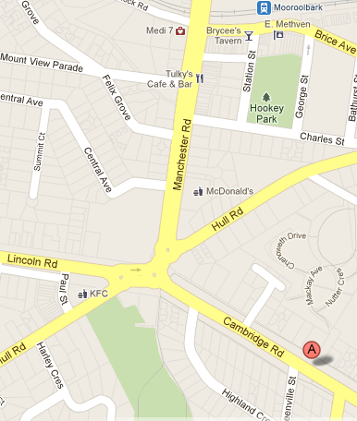
A: 43 Cambridge Road. Near the T-intersection of Hawthory and Cambridge Roads
Referral forms are available on our website
AcupunctureMooroolbark.com

